Evaluation: ET-OvR
Accuracy: 0.9536
Precision: 0.9536361793690167
Recall: 0.9536
F1 Score: 0.9535616281674701
Jaccard Index: 0.9118067849850441
Matthews CorrCoef: 0.9420273191883904
Cohen’s Kappa: 0.942
Specificity: 0.9884000000000001
AUC: 0.9963695
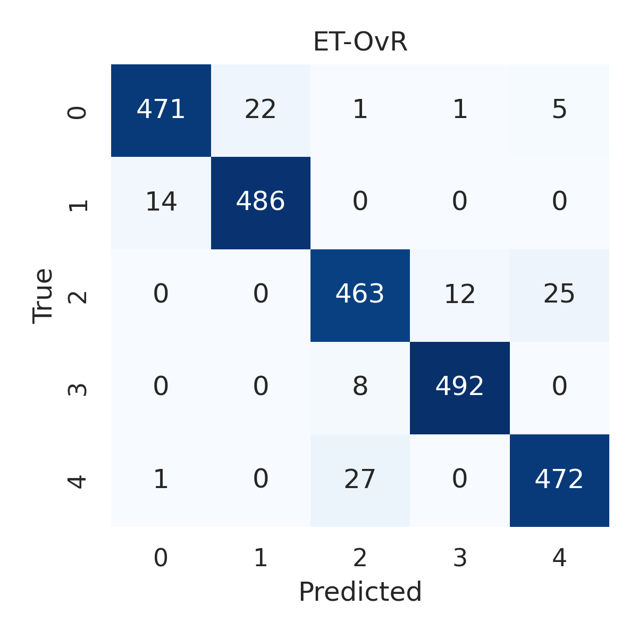

Combined ROC Curves
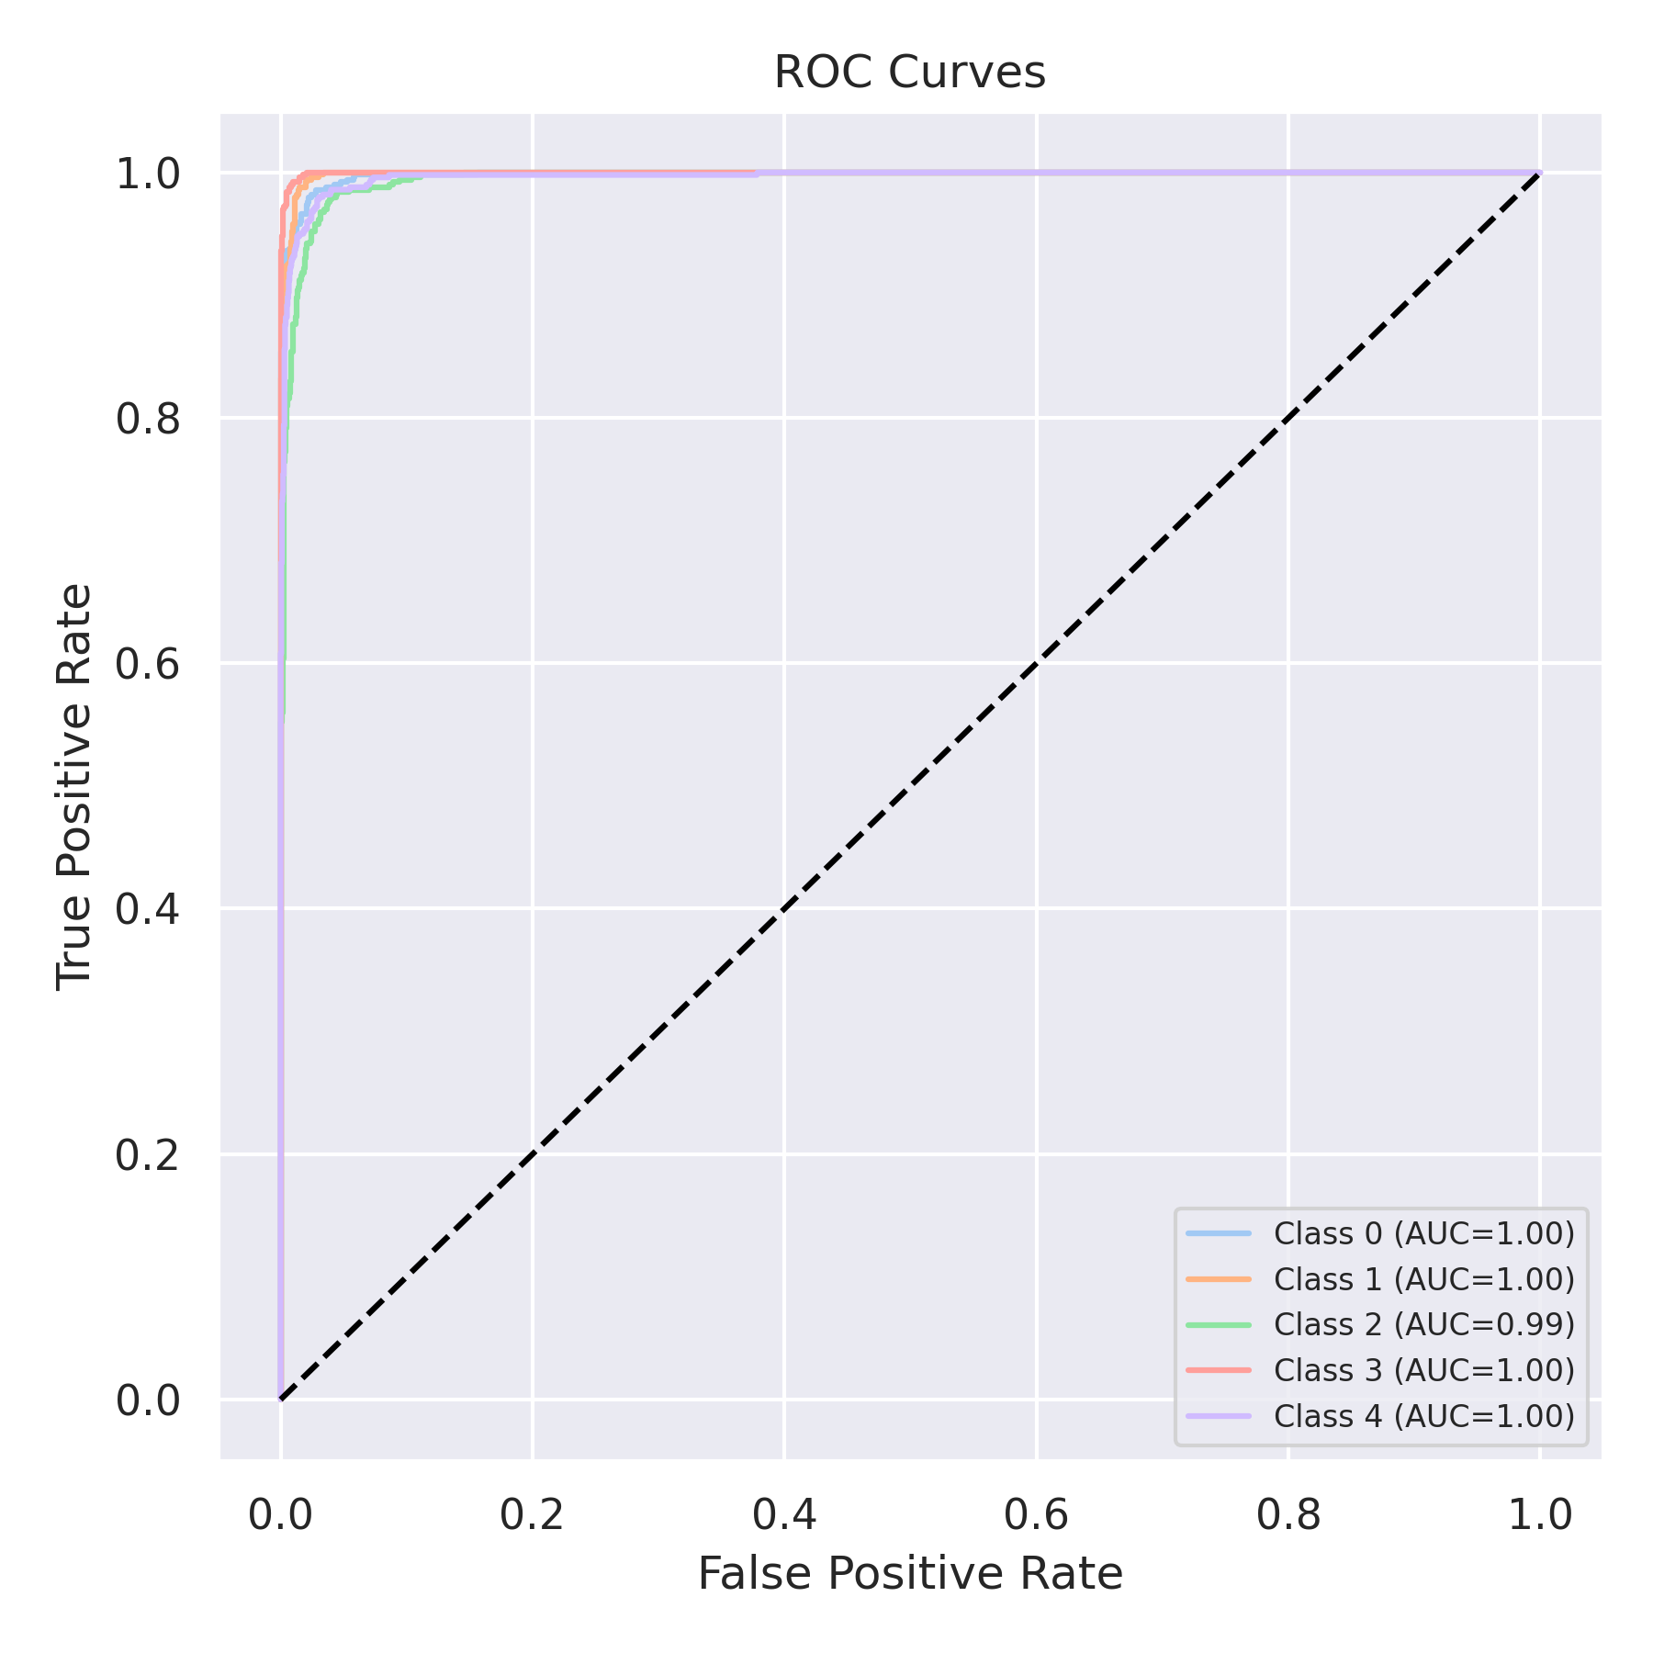

Evaluation: RF-OvR
Accuracy: 0.9468
Precision: 0.9467767286068373
Recall: 0.9468
F1 Score: 0.9467068365379094
Jaccard Index: 0.8996417622815363
Matthews CorrCoef: 0.9335393961937967
Cohen’s Kappa: 0.9335
Specificity: 0.9867000000000001
AUC: 0.9947219999999999
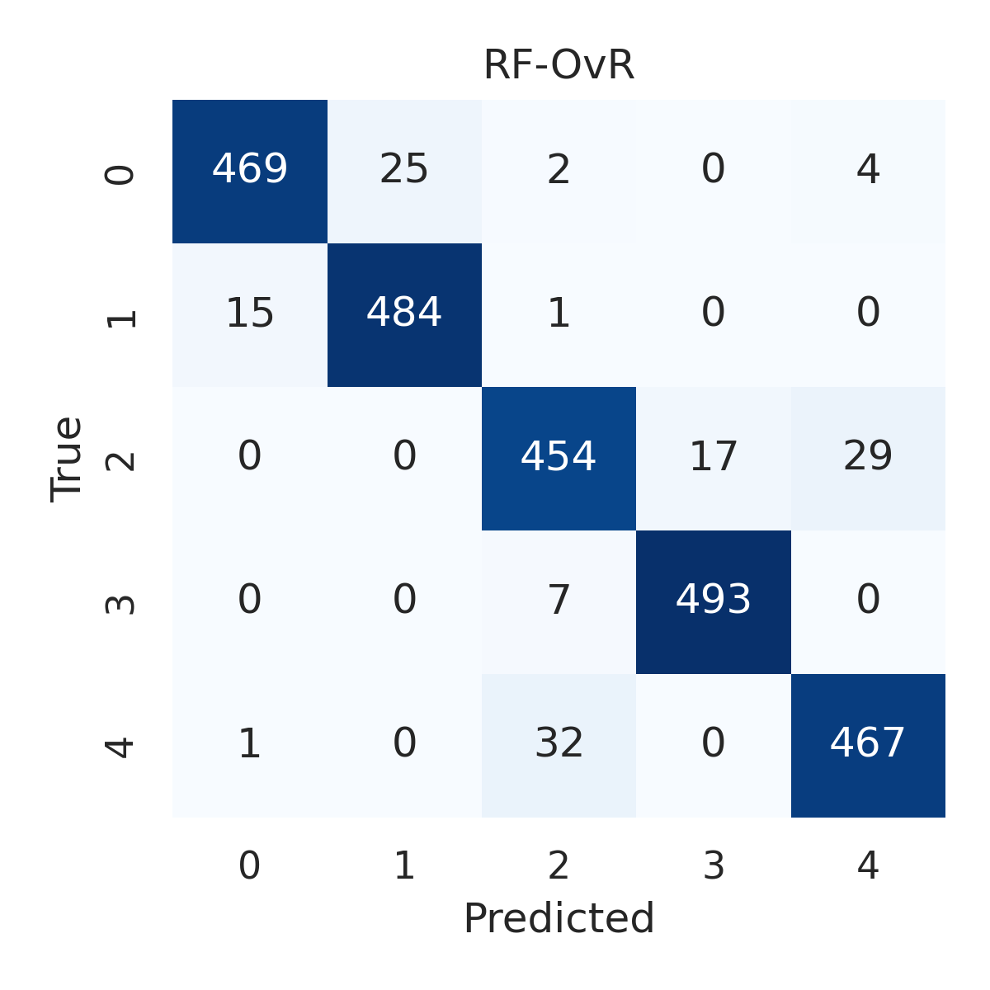

Combined ROC Curves
